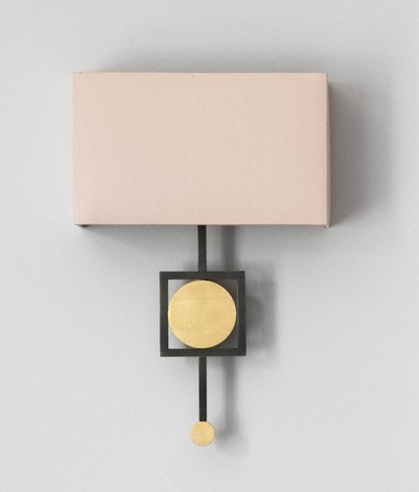  Bronze with hand-gilded gold discs |  | Silk Colours  Metalwork Finishes  Bronze with hand-gilded blush marble discs Bronze with hand-gilded pewter discs Bronze with hand-gilded champagne discs  Bronze with hand-gilded rose gold discs

AUREOL WALL LIGHT
Model Number — TL-AUWL

Width | Depth | Height | Lamp Holders | Max Wattage | Weight
Aureol Wall Light - TL-AUWL
11 ¾” | 4” | 17 ¾” | 2- E26 | 30W each | 5.5kg

A range of Tigermoth Lighting products are UL approved under the UL General Coverage Scheme.
UL File No. E499008
General:
All the lamp holders in our Aureol collection are Edison Screw (E26).

Made to USA standards and designed to operate at 120V / 60Hz

All measurements and weights are approximate - our lights are hand crafted so there will be some variation.

Please note, light sources are not supplied with UL Listed orders.

Assembly:
We recommend that you use a qualified electrician to install your light.

Our lights come with comprehensive installation instructions. They shouldn’t need much maintenance but we give you some information on that too.

Modifications available:
- Client’s own silk
- Any silk from Pongees 734 Indian Douppion or 431D Crepe Satin range

Call us for more information on modifications.
Made in England.
All our lights are designed and manufactured in England by skilled craftsmen and women.  All designs are copyright to Tigermoth Lighting Ltd. |  | Tigermoth Lighting is a Lighting Industry Association Quality Assured Company.

